**Dashboard Design**

|  |  |
| --- | --- |
| Date | 26 July 2024 |
| Team ID | - |
| Project Name | Global Food Production Trends and Analysis |
| Maximum Marks | 5 Marks |

**Activity 1: Interactive and visually appealing dashboards**

My dashboard includes features like:

* Clear and Intuitive Layout: Neatly organized sections for crop and fruit production.
* Appropriate Visualizations: Area charts, card visuals, bar charts, donut charts, and gauge visuals.
* Colour and Theming: A blue-themed colour palette for consistency and readability.
* Interactive Filters and Slicers: Year and entity slicers for user-led exploration.
* Drill-down Capabilities: Timeline-based trends for cereals like rice, wheat, maize.
* Responsive Design: Optimized visual spacing and alignment for clarity.
* Custom Visuals: Gauge chart for tea production, donut for maize distribution.
* Infographics: Visual icons and metrics enhance interpretability.

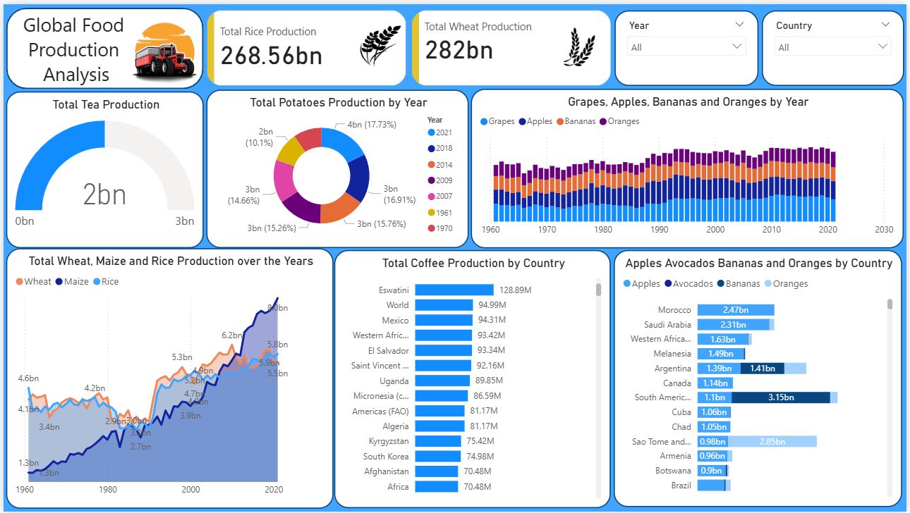

**Here are eight major outcomes from the dashboard:**

• **Wheat Production**: Total production from 1961 to 2023 was 282 billion tonnes, making it the most dominant crop.

• **Rice Production**: Recorded 269 billion tonnes, showing consistent growth and global dependence.

• **Tea Production**: Gauge chart indicates 2 billion tonnes, with notable regional variances.

• **Green Coffee Production**: Africa emerged as the top contributor, followed by Asia and the Americas.

• **Cereal Trend Analysis**: Wheat, maize, and rice production have all steadily increased, especially post-1980.

• **Grape Production**: Among all fruits, grapes had the highest total at 43 billion tonnes.

• **Regional Fruit Comparison**: Europe and Asia dominate in apple and banana production respectively.

• **Annual Maize Output**: Donut chart analysis showed specific peak years post-1990 for maize growth.